Name ________________________________ Date ________________________ A.P. Economics Opportunity Cost Worksheet

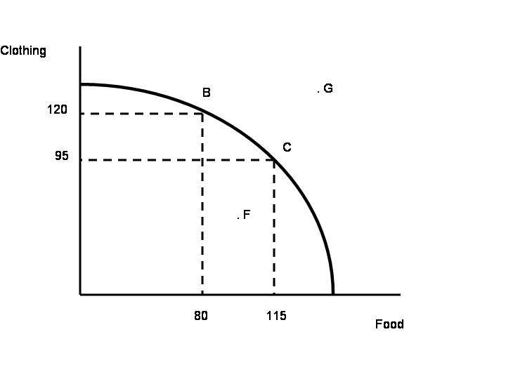
1. How much clothing is given up when moving from point B to point C?_________________________

2. What is the opportunity cost of moving from point B to point C? _____________________________

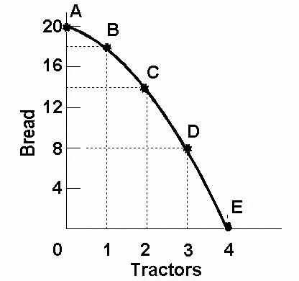

3. How many tractors are given up when moving from point C to point B? ________________________

4. What is the opportunity cost of moving from point D to point C? ______________________________
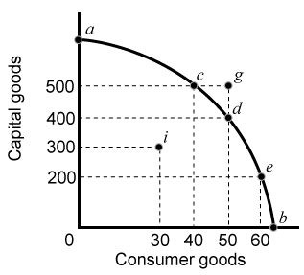

5. How many consumer goods are given up when moving from point e to point d? ________________

6. How many consumer goods are given up when moving from point d to point c? ________________

7. What is the opportunity cost of increasing capital good production from 400 to 500 units? _________

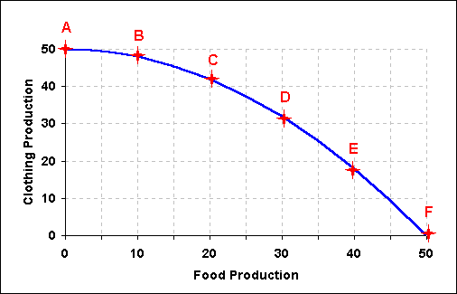

8. What is given up when moving from point B to point C? _____________________________________

9. What is the opportunity cost of moving from point E to point D? ______________________________
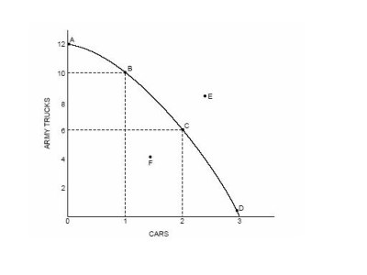
10. What is the opportunity cost of moving from point A to point B? ____________________________

11. What law of economics helps explain the difference between moving from points A to B from points
B to C? ___________________________________________________________________________

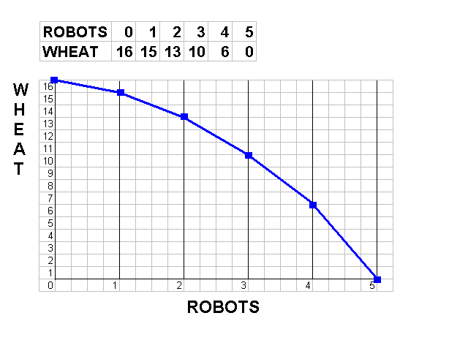
12. The value of the next best alternative in a trade off is known as ______________________________

13. Can the producer of wheat and robots produce 16 units of wheat and 5 robots simultaneously? Explain______________________________________________________________________________________________________________________________________________________________________________________________________________________________________________________________________________________________________________________________________________

